**Content Delivery Network**



**Azure Content Delivery Network (Azure CDN)** is Microsoft’s managed global CDN service that accelerates the delivery of your web content to users by caching it at strategically placed **edge servers** across the world.

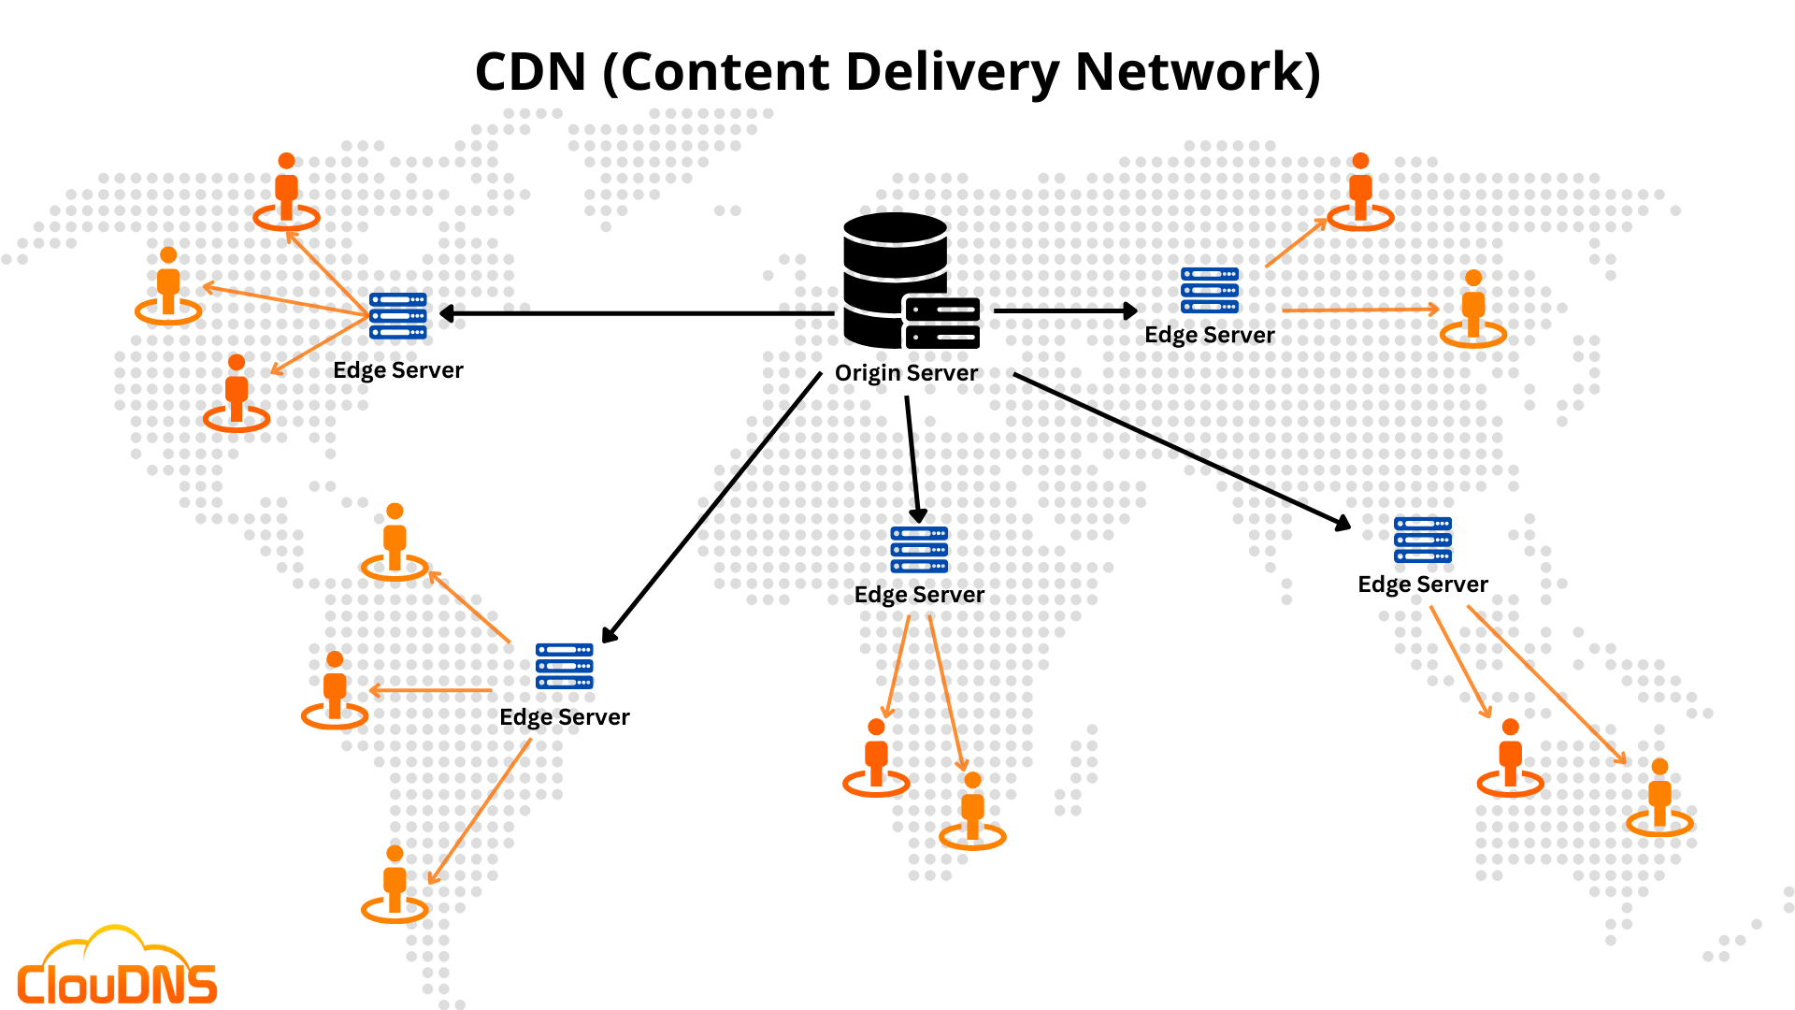

It’s fully integrated with other Azure services and can be used to deliver:

* Static files (images, CSS, JS)
* Dynamic content (with some optimization)
* Video streams
* APIs

**Features :**

1. **Global Edge Network** — Delivers content from the closest edge location to users.
2. **Caching** — Reduces origin load and speeds up static and dynamic content.
3. **HTTPS & Custom Domains** — Secure delivery with TLS and custom domain support.
4. **Integration with Azure Services** — Works seamlessly with Blob, Web Apps, Media, VMs.
5. **Analytics & Monitoring** — Insights into traffic, performance, and cache efficiency.